Registration Form
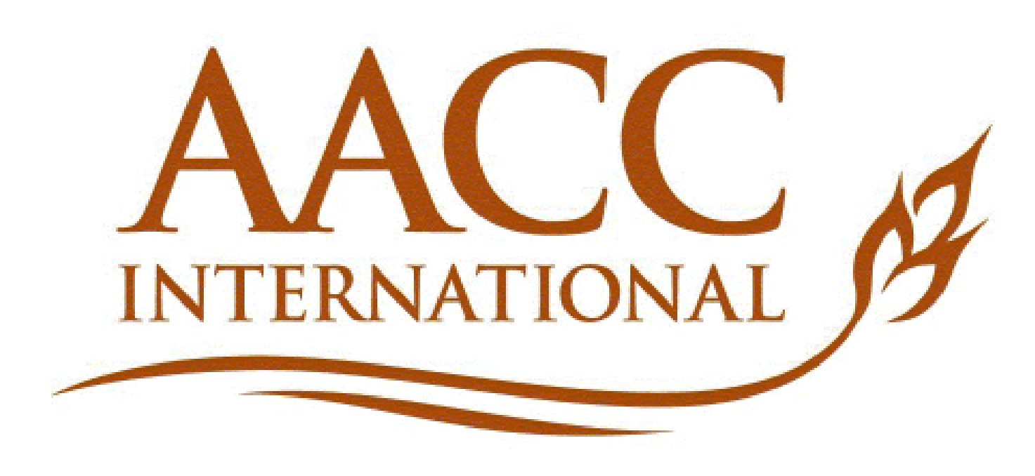
18th European Young Cereal Scientists and Technologists Workshop
April 15– 17, 2019
University of Camerino

Please double-click on the relevant boxes to select

Top of Form
Mr Mrs

Bottom of Form

Last Name:
First Name:

University/Organization/Company:

E-mail: Telephone:

Invoice Address (i.e. please provide address your finance department requires on invoice):

CONFERENCE FEES
Registration Fees / Includes accommodation, lunches, dinner, and proceedings.

Please tick the appropriate registration fee:
Top of Form
Student C&E Member (includes attendees to the 17th EYCSTW) €250
Bottom of Form
Top of Form
Student Non C&E Member (includes 1 year membership) €275
Bottom of Form
Top of Form
Senior/Industry C&E Member €310
Bottom of Form
Top of Form
Senior/Industry non C&E Member (includes 1 year membership) €335
Bottom of Form

Top of Form
Count me for lunch: Mon Tue Wed Vegetarian meals required:
Bottom of Form
Top of Form
Count me for Diner: Sun Mon Tue Vegetarian meals required:

Bottom of Form
Please list any other Special dietary requirement: ________________________________________________________________________________

PAYMENT METHOD

Payments should be made by bank transfer at:

Bank Name: ING
Account owner: Cereals&Europe
Bank code: INGB
SWIFT code: INGBNL2A
Account number: 0004149475
IBAN: NL06INGB0004149475

REGISTRATION INFORMATION
- Completed registration must be sent as Word documents by March 24th, 2019 to: cerealsandeurope@scisoc.org

- Payment is due before April 7th, 2019

- Refunds for cancellations: 25% of the registration fees will be taken if your cancellation is received at the C&E office before April 9th, 2019. After this date 100% of the registration fees will be taken in case of cancellation

- For inquiries, please contact C&E (cerealsandeurope@scisoc.org)

